Đoàn Trung Tấn
1150080035
11THMT
Bài Tập 1:
MainActivity.java
package com.example.maytinh;
import androidx.appcompat.app.AppCompatActivity;
import android.os.Bundle;
import android.view.View;
import android.widget.Button;
import android.widget.EditText;
import android.widget.TextView;
import android.widget.Toast;
public class MainActivity extends AppCompatActivity {
EditText edtA, edtB;
TextView tvResult;
Button btnAdd, btnSub, btnMul, btnDiv, btnMod;
@Override
protected void onCreate(Bundle savedInstanceState) {
super.onCreate(savedInstanceState);
setContentView(R.layout.activity_main);
edtA = findViewById(R.id.edtA);
edtB = findViewById(R.id.edtB);
tvResult = findViewById(R.id.tvResult);
btnAdd = findViewById(R.id.btnAdd);
btnSub = findViewById(R.id.btnSub);
btnMul = findViewById(R.id.btnMul);
btnDiv = findViewById(R.id.btnDiv);
btnMod = findViewById(R.id.btnMod);
View.OnClickListener listener = new View.OnClickListener() {
@Override
public void onClick(View v) {
double a, b;
try {
a = Double.parseDouble(edtA.getText().toString());
b = Double.parseDouble(edtB.getText().toString());
} catch (NumberFormatException e) {
Toast.makeText(MainActivity.this, "Vui lòng nhập hai số hợp lệ!", Toast.LENGTH_SHORT).show();
return;
}
double result = 0.0;
int id = v.getId();
if (id == R.id.btnAdd) {
result = a + b;
} else if (id == R.id.btnSub) {
result = a - b;
} else if (id == R.id.btnMul) {
result = a * b;
} else if (id == R.id.btnDiv) {
if (b == 0) {
Toast.makeText(MainActivity.this, "Không thể chia cho 0!", Toast.LENGTH_SHORT).show();
return;
}
result = a / b;
} else if (id == R.id.btnMod) {
result = a % b;
}
tvResult.setText(String.format("Result: %.2f", result));
}
};
btnAdd.setOnClickListener(listener);
btnSub.setOnClickListener(listener);
btnMul.setOnClickListener(listener);
btnDiv.setOnClickListener(listener);
btnMod.setOnClickListener(listener);
}
}
activity_main.xml
<?xml version="1.0" encoding="utf-8"?>
<LinearLayout xmlns:android="http://schemas.android.com/apk/res/android"
android:layout_width="match_parent"
android:layout_height="match_parent"
android:orientation="vertical"
android:gravity="center_horizontal"
android:padding="16dp">
<EditText
android:id="@+id/edtA"
android:layout_width="match_parent"
android:layout_height="wrap_content"
android:hint="Nhập số thứ nhất"
android:inputType="numberDecimal"
android:textAlignment="center"/>
<EditText
android:id="@+id/edtB"
android:layout_width="match_parent"
android:layout_height="wrap_content"
android:hint="Nhập số thứ hai"
android:inputType="numberDecimal"
android:textAlignment="center"
android:layout_marginTop="8dp"/>
<TextView
android:id="@+id/tvResult"
android:layout_width="wrap_content"
android:layout_height="wrap_content"
android:text="Result: "
android:textSize="18sp"
android:textStyle="bold"
android:layout_margin="12dp"/>
<LinearLayout
android:layout_width="match_parent"
android:layout_height="wrap_content"
android:orientation="horizontal"
android:gravity="center"
android:layout_marginTop="12dp">
<Button
android:id="@+id/btnAdd"
android:layout_width="60dp"
android:layout_height="60dp"
android:text="+"
android:backgroundTint="#673AB7"
android:textColor="@android:color/white"/>
<Button
android:id="@+id/btnSub"
android:layout_width="60dp"
android:layout_height="60dp"
android:text="-"
android:backgroundTint="#673AB7"
android:textColor="@android:color/white"
android:layout_marginStart="6dp"/>
<Button
android:id="@+id/btnMul"
android:layout_width="60dp"
android:layout_height="60dp"
android:text="*"
android:backgroundTint="#673AB7"
android:textColor="@android:color/white"
android:layout_marginStart="6dp"/>
<Button
android:id="@+id/btnDiv"
android:layout_width="60dp"
android:layout_height="60dp"
android:text="/"
android:backgroundTint="#673AB7"
android:textColor="@android:color/white"
android:layout_marginStart="6dp"/>
<Button
android:id="@+id/btnMod"
android:layout_width="60dp"
android:layout_height="60dp"
android:text="%"
android:backgroundTint="#673AB7"
android:textColor="@android:color/white"
android:layout_marginStart="6dp"/>
</LinearLayout>
</LinearLayout>
Kết Quả:
-Phép cộng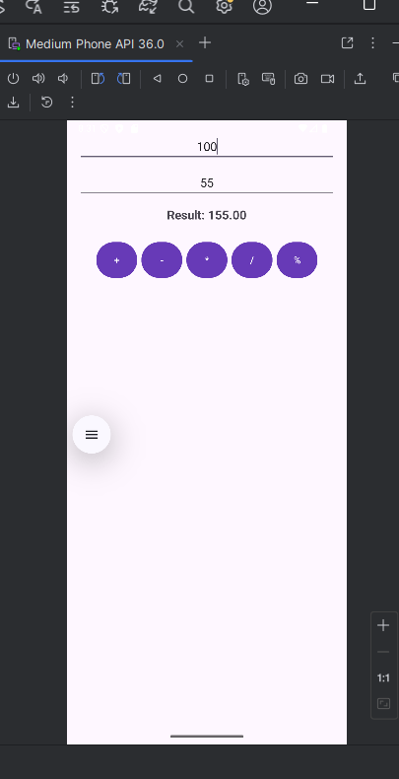

-Phép trừ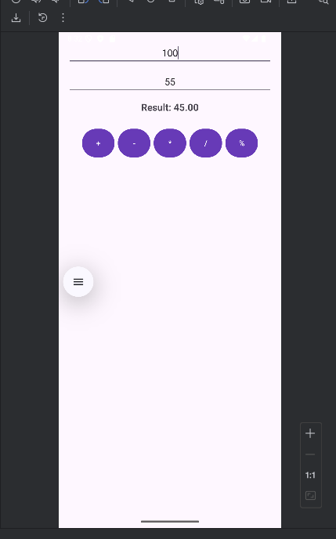
-Phép nhân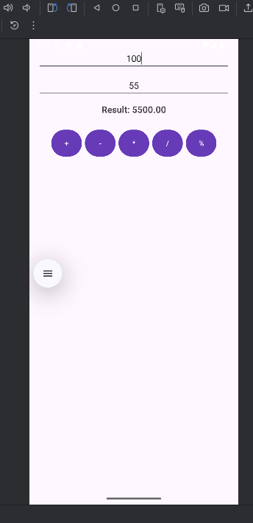
-Phép chia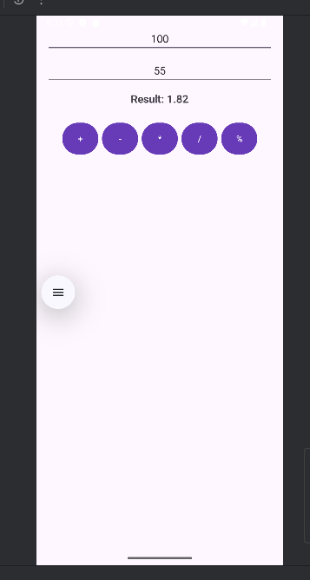
-Phần trăm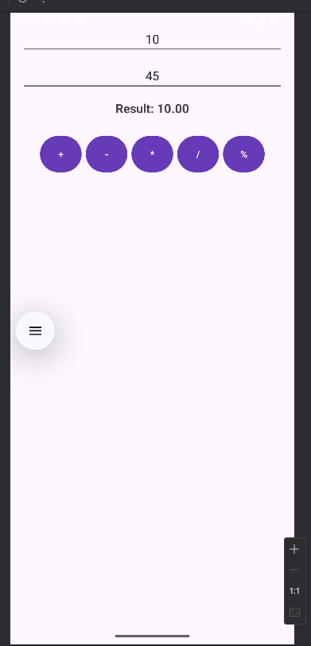
Bài tập 2
MainActivity.java
package com.example.xucxac;
import androidx.appcompat.app.AppCompatActivity;
import android.os.Bundle;
import android.view.View;
import android.widget.Button;
import android.widget.ImageView;
import java.util.Random;
public class MainActivity extends AppCompatActivity {
ImageView imgDice;
Button btnRoll;
Random random = new Random();
@Override
protected void onCreate(Bundle savedInstanceState) {
super.onCreate(savedInstanceState);
setContentView(R.layout.activity_main);
imgDice = findViewById(R.id.imgDice);
btnRoll = findViewById(R.id.btnRoll);
btnRoll.setOnClickListener(new View.OnClickListener() {
@Override
public void onClick(View v) {
int number = random.nextInt(6) + 1;
int imageId = getResources().getIdentifier("dice_" + number, "drawable", getPackageName());
imgDice.setImageResource(imageId);
}
});
}
}
activity_main.xml
<?xml version="1.0" encoding="utf-8"?>
<LinearLayout xmlns:android="http://schemas.android.com/apk/res/android"
android:layout_width="match_parent"
android:layout_height="match_parent"
android:orientation="vertical"
android:gravity="center"
android:background="#FFFFFF">
<ImageView
android:id="@+id/imgDice"
android:layout_width="150dp"
android:layout_height="150dp"
android:src="@drawable/dice_1"
android:layout_marginBottom="24dp" />
<Button
android:id="@+id/btnRoll"
android:layout_width="wrap_content"
android:layout_height="wrap_content"
android:text="Roll Dice"
android:backgroundTint="#673AB7"
android:textColor="@android:color/white"
android:padding="12dp"/>
</LinearLayout>
Kết quả
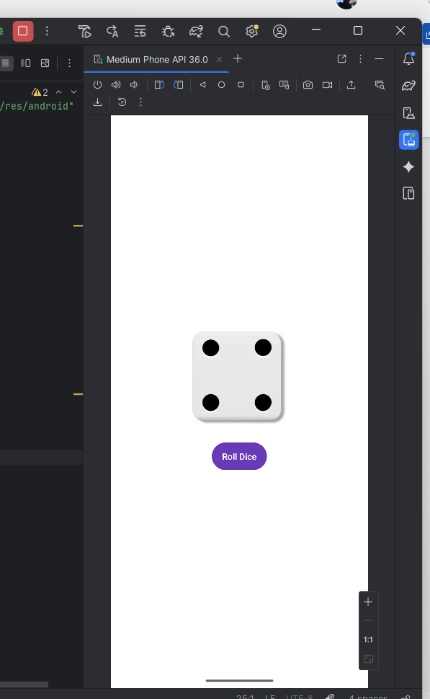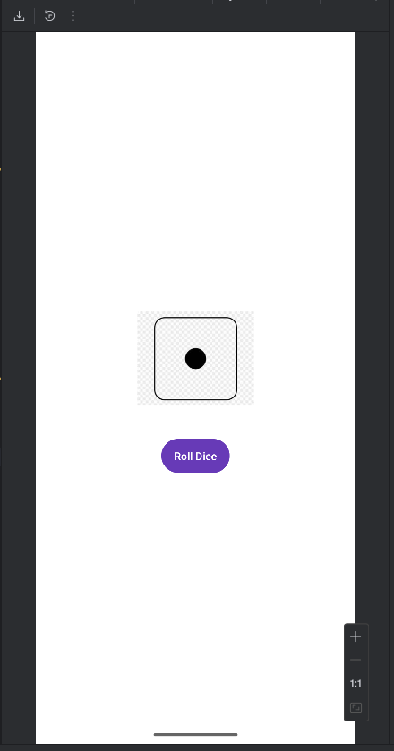
Bài tập 3:
MainActivity.java
package com.example.dienthoai;
import androidx.appcompat.app.AppCompatActivity;
import androidx.core.app.ActivityCompat;
import android.Manifest;
import android.content.Intent;
import android.content.pm.PackageManager;
import android.net.Uri;
import android.os.Bundle;
import android.view.View;
import android.widget.Button;
import android.widget.EditText;
import android.widget.Toast;
public class MainActivity extends AppCompatActivity {
EditText edtPhone;
Button btnCall, btnSMS;
@Override
protected void onCreate(Bundle savedInstanceState) {
super.onCreate(savedInstanceState);
setContentView(R.layout.activity_main);
edtPhone = findViewById(R.id.edtPhone);
btnCall = findViewById(R.id.btnCall);
btnSMS = findViewById(R.id.btnSMS);
btnCall.setOnClickListener(new View.OnClickListener() {
@Override
public void onClick(View v) {
String phone = edtPhone.getText().toString().trim();
if (phone.isEmpty()) {
Toast.makeText(MainActivity.this, "Vui lòng nhập số điện thoại", Toast.LENGTH_SHORT).show();
return;
}
Intent callIntent = new Intent(Intent.ACTION_CALL);
callIntent.setData(Uri.parse("tel:" + phone));
if (ActivityCompat.checkSelfPermission(MainActivity.this, Manifest.permission.CALL_PHONE)
!= PackageManager.PERMISSION_GRANTED) {
ActivityCompat.requestPermissions(MainActivity.this, new String[]{Manifest.permission.CALL_PHONE}, 1);
return;
}
startActivity(callIntent);
}
});
btnSMS.setOnClickListener(new View.OnClickListener() {
@Override
public void onClick(View v) {
String phone = edtPhone.getText().toString().trim();
if (phone.isEmpty()) {
Toast.makeText(MainActivity.this, "Vui lòng nhập số điện thoại", Toast.LENGTH_SHORT).show();
return;
}
Intent smsIntent = new Intent(Intent.ACTION_VIEW, Uri.fromParts("sms", phone, null));
smsIntent.putExtra("sms_body", "Xin chào, đây là tin nhắn thử!");
startActivity(smsIntent);
}
});
}
}
activity_main.xml
<?xml version="1.0" encoding="utf-8"?>
<LinearLayout xmlns:android="http://schemas.android.com/apk/res/android"
android:layout_width="match_parent"
android:layout_height="match_parent"
android:orientation="vertical"
android:gravity="center"
android:padding="24dp"
android:background="#FFFFFF">
<EditText
android:id="@+id/edtPhone"
android:layout_width="match_parent"
android:layout_height="wrap_content"
android:hint="Nhập số điện thoại"
android:inputType="phone"
android:textAlignment="center"
android:layout_marginBottom="16dp"/>
<Button
android:id="@+id/btnCall"
android:layout_width="match_parent"
android:layout_height="wrap_content"
android:text="Call"
android:backgroundTint="#673AB7"
android:textColor="@android:color/white"
android:layout_marginBottom="16dp"/>
<Button
android:id="@+id/btnSMS"
android:layout_width="match_parent"
android:layout_height="wrap_content"
android:text="Send SMS"
android:backgroundTint="#673AB7"
android:textColor="@android:color/white"/>
</LinearLayout>
AndroidManifest.xml
<?xml version="1.0" encoding="utf-8"?>
<manifest xmlns:android="http://schemas.android.com/apk/res/android"
xmlns:tools="http://schemas.android.com/tools">
<uses-permission android:name="android.permission.CALL_PHONE"/>
<uses-permission android:name="android.permission.SEND_SMS"/>
<application
android:allowBackup="true"
android:dataExtractionRules="@xml/data_extraction_rules"
android:fullBackupContent="@xml/backup_rules"
android:icon="@mipmap/ic_launcher"
android:label="@string/app_name"
android:roundIcon="@mipmap/ic_launcher_round"
android:supportsRtl="true"
android:theme="@style/Theme.Dienthoai">
<activity
android:name=".MainActivity"
android:exported="true">
<intent-filter>
<action android:name="android.intent.action.MAIN" />
<category android:name="android.intent.category.LAUNCHER" />
</intent-filter>
</activity>
</application>
</manifest>
Kết quả:
